**BX3083: STRATEGIC MARKETING**

ASSESSMENT TASK 2 COLLEGE OF BUSINESS, LAW AND GOVERNANCE



**INDIVIDUAL TASK COVER SHEET**

|  |  |  |  |  |  |  |  |  |  |
| --- | --- | --- | --- | --- | --- | --- | --- | --- | --- |
| *Student*  *Please sign, date and attach cover sheet to front of assessment task for all hard copy submissions* | | | | | | | | | |
| **SUBJECT CODE** | BX3083 | | | | | | | | |
| **STUDENT FAMILY NAME** | **Student Given Name** | **JCU Student Number** | | | | | | | |
| Tran | Le Binh | 1 | 3 | 4 | 7 | 6 | 1 | 1 | 2 |
| **ASSESSMENT TITLE** | Case Study | | | | | | | | |
| **DUE DATE** | 29/12/2018 | | | | | | | | |
| **LECTURER NAME** | Val Philip Ortega | | | | | | | | |
| **TUTOR NAME** | Val Philip Ortega | | | | | | | | |
| **Student Declaration**   1. This assignment is my original work and no part has been copied/ reproduced from any other person’s work or from any other source, except where acknowledgement has been made (see *Learning, Teaching and Assessment Policy 5.1*). 2. This work has not been submitted for any other course/subject (see *Learning, Teaching and Assessment Policy 5.9*). 3. This assignment has not been written for me. 4. I hold a copy of this assignment and can produce a copy if requested. 5. This work may be used for the purposes of moderation and identifying plagiarism. 6. I give permission for a copy of this marked assignment to be retained by the College for benchmarking and course review and accreditation purposes.   [Learning, Teaching and Assessment Policy](http://www.jcu.edu.au/policy/allitoz/JCU_076643.html) 5.1. A student who submits work containing plagiarised material for assessment will be subject to the provisions of the [Student Academic Misconduct Requirements.](http://www.jcu.edu.au/policy/allitoz/JCUDEV_005375.html)  **Note definition of plagiarism and self plagiarism in Learning, Teaching and Assessment Policy:**  **Plagiarism:** reproduction without acknowledgement of another person’s words, work or expressed thoughts from any source. The definition of words, works and thoughts includes such representations as diagrams, drawings, sketches, pictures, objects, text, lecture hand-outs, artistic works and other such expressions of ideas, but hereafter the term ‘work’ is used to embrace all of these. Plagiarism comprises not only direct copying of aspects of another person’s work but also the reproduction, even if slightly rewritten or adapted, of someone else’s ideas. In both cases, someone else’s work is presented as the student’s own. Under the Australian *Copyright Act 1968* a copyright owner can take legal action in the courts against a party who has infringed their copyright.  **Self Plagiarism:** the use of one’s own previously assessed material being resubmitted without acknowledgement or citing of the original.  **Student Signature**  Tran Le Binh Submission date 29/12/ 2018 | | | | | | | | | |

**Table of Content**

1. Discuss the product life cycle (PLC) of cheese and butter and the issues that need to be addressed by the marketers of these two products. In addressing this question you must include a discussion on the marketing strategies that could be used by dairy producers at each stage of the PLC. 3

1.1. Cheese 3

1.2. Butter 5

1.3. Issues to be addressed 5

1.4. Discussion about marketing strategies could be used at each stage of the PLC 6

1.4.1. Introduction: 6

1.4.2. Growth: 8

1.4.3. Maturity 9

1.4.4. Decline 9

2. Using the information provided in Exhibit 4 and 5, elaborate and interpret a portfolio matrix for the dairy producer DPA. In responding to this question, it is recommended only milk sales for 2008-09 and 2009-10 periods are used. 9

2.1. Dogs 10

2.2. Question marks 11

3. How do the major supermarket pricing strategies affect the attractiveness of the dairy industry? What steps can dairy producers take to best deal with the market power of the major supermarkets? 11

3.1. The major supermarket pricing strategies 11

3.2. Steps 13

**Table of Figure**

Figure 1: The Cheese’s Product Life Cycle 3

Figure 2: Cheese Brand 4

Figure 3: Butter’s Product Life Cycle 5

Figure 4: The Products Layers 6

Figure 5: The Framework for Setting Price 7

Figure 6: Types of Channel Intermediaries 8

Figure 7: Types of Consumer Channels 8

Figure 8: Market growth rate and Relative market share Calculation 10

Figure 9: The Portfolio Matrix for Diary Product DPA 10

Figure 10: The Australian Major Supermarkets Setting Price Framework 12

# Discuss the product life cycle (PLC) of cheese and butter and the issues that need to be addressed by the marketers of these two products. In addressing this question you must include a discussion on the marketing strategies that could be used by dairy producers at each stage of the PLC.

## Cheese

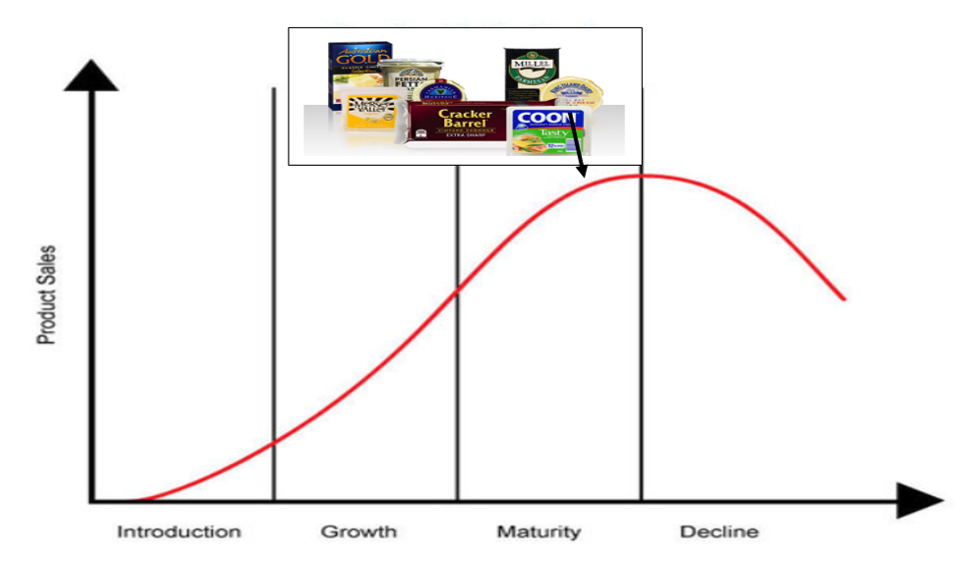

Figure : The Cheese’s Product Life Cycle

The product life cycle of Cheese lies in the maturity stage because

* From 2008 to 2010, there were about 12.9 kg per capita consumption in the Australian market.
* In 2010, there were about 349361 tonnes of cheese produced in the Australian market. To be more specific, the Cheddar cheese were about 164220 tonnes, the Fresh cheese were 81674 tonnes, the Semi-hard cheese were 82481 tonnes, the Hard grating cheese were 12236 tonnes, the Mould cheese were 8660 tonnes.
* In fact, several cheese brands have participated in the cheese market (Jager, 2018).

|  |  |
| --- | --- |
| **Type of Cheese** | **Company Name** |
| Cheddar Cheese | Bega Heritage Reserve Vintage |
| Goat’s/Sheep’s/Buffalo Milk Cheese | Berrys Creek Riverine Blue (Berry Creek Gourmet Cheese) |
| Blue Cheese | Berrys Creek Tarwin Blue (Berrys Creek Gourmet Cheese) |
| Fresh Unripened Cheese | Montefiore Ovoline (Montefiore Cheese) |
| White Mould Cheese | Sing Island Dairy Discovery Ash Brie 175g (Lion Dairy & Drinks-King Island) |
| Hard Cheese | Mil Lel Superior Parmesan (Warrnambool Cheese and Butter Factory) |
| Semi Hard/Eye Cheese | Section 28 Monforte (Section28 Artisan Cheeses) |
| Flavoured Cheese | Section 28 Monte Diavolo (Section 28 Artisan Cheeses) |
| Washed Rind/Mixed Rind Cheese | Woombye Blackall Gold Washed Rind (Woombye Cheese Company) |

Figure : Cheese Brand

It is interesting to notice that although the Cheese products are in the maturity stage, the consumption increased slightly, which was about from 11.6 kg per capita to 12.9 kg per capita from 2001 to 2010. Moreover, the production of some important types declined such as Cheddar, Fresh, Semi-hard, Hard grating from 2001 to 2010, which was about a decline of 31667 tonnes, 1975 tonnes, 8233 tonnes and 1031 tonnes, respectively. There was only an increase of Mould cheese from 2001 to 2010, which was about from 4833 to 8660 tonnes.

Hence, the fact of reducing the consumption of Cheddar, Fresh, Semi-hard, Hard grating proves that a high probability of showing the product life cycle of Cheese will be in the decline stage in the near future.

## Butter

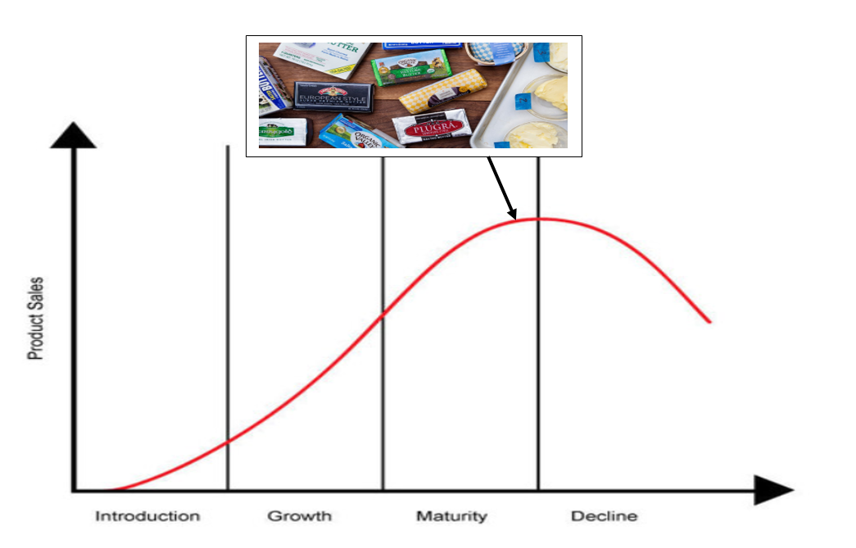

Figure : Butter’s Product Life Cycle

The product life cycle of Butter lies in the maturity stage because

* From 2008 to 2010, there were about 3.8 kg per capita consumption in the Australian market.
* In 2010, there were about 100143 tonnes of butter/butter blend (CBE) and 28245 tonnes of Anhydrous Milk Fat (CBE) produced in the Australian market.
* In fact, several butter brands have participated in the cheese market (Hoskin, 2018). For example, there are Devondale Unsalted Butter, Ballantyne Cultured Style Unsalted Butter, Allowrie Cultured Unsalted European Style Butter, Kerrygold Pure Irish Unsalted Butter & Lurpak Unsalted Butter (Danish), Woolworths Unsalted Butter, Western Star Unsalted Cultured Butter & Mainland Pure Unsalted Butter, Coles Unsalted Butter, Australian Organic Unsalted Butter, Pepe Saya Unsalted Butter

Similar to the Cheese product, although the Butter products are in the maturity stage, the consumption increased slightly, which was about from 3.4 kg per capita to 3.8 kg per capita from 2001 to 2010. Moreover, the production of butter/butter blend (CBE) and Anhydrous Milk Fat (CBE) declined from 2001 to 2010, which was about a decline of 4997 tonnes and 13283 tonnes, respectively.

Hence, the fact of reducing the consumption of Butter products proves that a high probability of showing the product life cycle of Butter will be in the decline stage in the near future.

## Issues to be addressed

* Identify the reasons for a significant decline in production and a slightly increase in consumption.
* Recognize the changes of customers’ taste and preferences of two products.
* Indicate the target market.
* Re-establish the marketing strategies.

## Discussion about marketing strategies could be used at each stage of the PLC

### Introduction:

This is known as the first stage of product life cycle where there is a slow growth and non-existent profits, new and unknown products, no direct competitors (Jain et al, 2012). The marketing objectives is to let customers reach and purchase the products (Solomon et al, 2014).

***Product:***

|  |  |
| --- | --- |
| **Layers** | **Description** |
| Core | Provide the product benefits to consumers by educating the advantages and disadvantages of consuming Butter and Cheese in a concise and perspicuous message. For instance,   * Butter: Boosting Minerals Absorbability or Occurring Health Threat Place in Your Hand. * Cheese: Achieving The Strength Of Bones, Teeth And Weight Or Rising The Cholesterol Level Depends On You |
| Actual | * Create the products brand and logo that makes consumers recognize and pronounce straightforwardly. * Select the theme color, textures, products dimension for exterior design that draws consumers’ attention. * For the packaging, there are some information needed to provide such as warnings, direction and use, photo of actual product, product benefits, nutritional information, package materials protection, * Highlight the quality of products |
| Augmented | The customer support service hotline or email, the product use instruction, the company address must be provided on the products package that makes consumers contact straightforwardly in case of emergency. |

Figure : The Products Layers

***Promotion:***

It is compulsory to focus on the primary-demand advertising in the former part of the introduction stage where there are no direct competitors (Jain et al, 2012). It means to stimulate demand for product class or entire industry rather than brand (Belch et al, 2014). The demand stimulation can be achieved by educating the benefits and drawbacks when consuming Butter or Cheese. In the latter part of the introduction stage, it requires to concentrate on generating secondary demand, which means that there is brand equity (Jain et al, 2012). Hence, creating the products brand makes consumers straightforward to recognize and pronounce.

***Price:***

The company has two decisions when setting the products price. Firstly, it may be higher to recover the R&D costs or secondly, it may be lower to attract a large number of consumers, which depends on company performance (Solomon et al, 2014).

There is a combination of promotion and price to create the strategy alternatives such as high price/high promotion, high price/low promotion, low price/low promotion, low price/high promotion (Jain et al, 2012).

Moreover, the marketers should establish the price strategy depending on the company scales, the products quality, distribution systems, market demand. Some pricing strategies should thoroughly investigate such as Market skimming strategy, Penetration strategy, Going rate pricing strategy, Value pricing, Loss leader pricing, Price discrimination strategy, Predatory pricing strategy, Psychological pricing strategy. The marketers should refer the framework for setting price, which is provided in Figure 5 with the pricing strategy in order to establish the proper price policy of each Butter and Cheese products.

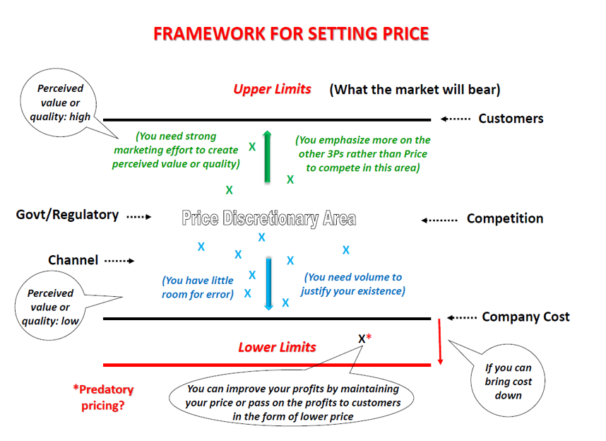

Figure : The Framework for Setting Price

***Place:***

To distribute the Butter and Cheese to customers, the marketers must consider the selection of distribution channels or consumer channels, which is provided in Figure 6 and 7

|  |  |
| --- | --- |
| Independent Intermediaries | |
| Merchant wholesalers | Take title to goods from the cheese or butter company manufacturers and sell the product to retailers and other B2B customers. |
| Merchandise agents or brokers | Provide services in exchange for commissions but do not involve in taking title to the products (Solomon et al, 2014). |
| Manufacturer-owned intermediaries | |
| Manufacturer’s showrooms | The cheese or butter companies manufacturer displays the products for customers to visit. |
| Sales offices | Do not involve in carrying inventory but providing selling functions for the manufacturer in a designated place in order to minimize selling costs and provide better service (Solomon et al, 2014). |

Figure : Types of Channel Intermediaries

|  |  |
| --- | --- |
| Direct channel | The Butter and Cheese company manufactures sell directly to customers  Producer → Consumer |
| Indirect channels | The Butter and Cheese company manufactures reach customers through retailers or other intermediaries  Producer → Retailer → Consumer  Producer → Wholesaler → Retailer → Consumer  Producer → Wholesaler → Wholesaler → Retailer → Consumer |

Figure : Types of Consumer Channels

### Growth:

This stage shows a substantial increase in sales and profits where there is consumer acceptance and the potential competitors enter the market (Jain et al, 2012). The marketing objectives is to encourage the purchase repetition by positioning the products brand in the high quality and value (Solomon et al, 2014). The marketers must re-identify the market segmentation and re-structure the marketing strategies to raise the market share.

***Product:***

Creating new products variation accompanying with features, models, benefits and proposing the supplementary company policy to encourage brand loyalty. The marketers provide more information to prove that beside the Butter and Cheese consumption through drinking and eating, they also can be used in cuisine, decoration.

***Price:***

Due to the participation of various competitors in the dairy industry, the price must reduce or maintain the high price depending on company marketing strategy and the unique ingredient. Although there are various competitors in cheese market, these cheese product brands still consider as the 5 most expensive cheeses in the world. For instance, the Pule Cheese costs $600 per pound, the White Stilton Gold costs $420 per pound, the Wyke Farms Cheddar costs $200 per pound, the Extra Old Bitto costs $150 per pound and the Caciocavallo Podolico costs $50 per pound (EasternEye, 2018).

***Promotion:***

Due to the participation of various competitors in the dairy industry, the promotion must be heavily advertised, particularly the sales promotion and mainly focus on new primary-demand and establish secondary-demand advertising (Jain et al, 2012). The choice of specific product brand affects the customers’ preference, product position.

***Place:***

The marketers must seek out the additional new distribution channels. The thorough research on B2C and C2C is required to expand the market share.

### Maturity

The phase shows the intense competition in a market, a fight for market share, peak sales and then begin to level off and narrow profit margins (Solomon et al, 2014). Simultaneously, there is a picture of saturating in domestic market. The marketing objectives is to still attract new customers. Especially, the company establish their international companies in Asian, Oceania countries to gain more market share and revenue. The participation in this blue ocean strategy makes the Cheese and Butter product life cycle not skewing in the decline stage. Moreover, this also creates a significant change in humanity evolution by removing the concept of consuming Cheese and Butter products.

***Product:***

The new features must be added regarding sizes, colors, attachments, benefits.

***Price:***

The price promotion offers and the price maintain

***Promotion:***

The promotion strategy must still remain with the persuasive and reliable advertisement.

***Place:***

The new channels of distribution must be discovered. The businesses running out of countries boundary makes company gain various distribution channels.

### Decline

The final stage expresses a decrease in sales as well as customer preferences. The invention of new marketing strategies could not draw consumers’ attention and interests. This requires the company to reform their policy such as revolutionize managerial style, increase the investment in product quality.

# Using the information provided in Exhibit 4 and 5, elaborate and interpret a portfolio matrix for the dairy producer DPA. In responding to this question, it is recommended only milk sales for 2008-09 and 2009-10 periods are used.

|  |  |  |
| --- | --- | --- |
| Type of milk | Market growth rate | Relative market share |
| Regular | (1133-1136) / 1136 = -0.3% | 15% / 35% = 0.43 |
| Reduced fat | (590-569) / 569 = 3.7% | 25% / 34% = 0.74 |
| Non-fat | (119-118) / 118 = 0.8% | 45% / 24% = 1.88 |
| Flavored | (215-210) / 210 = 2.4% | 20% / 39% = 0.51 |
| UHT | (211-196) / 196 = 7.7% | 10% / 43% = 0.23 |

Figure : Market growth rate and Relative market share Calculation

The market growth rate ratio: every 2 cm equals to 1% and the relative market share ratio: every 5 cm equals to 1 times

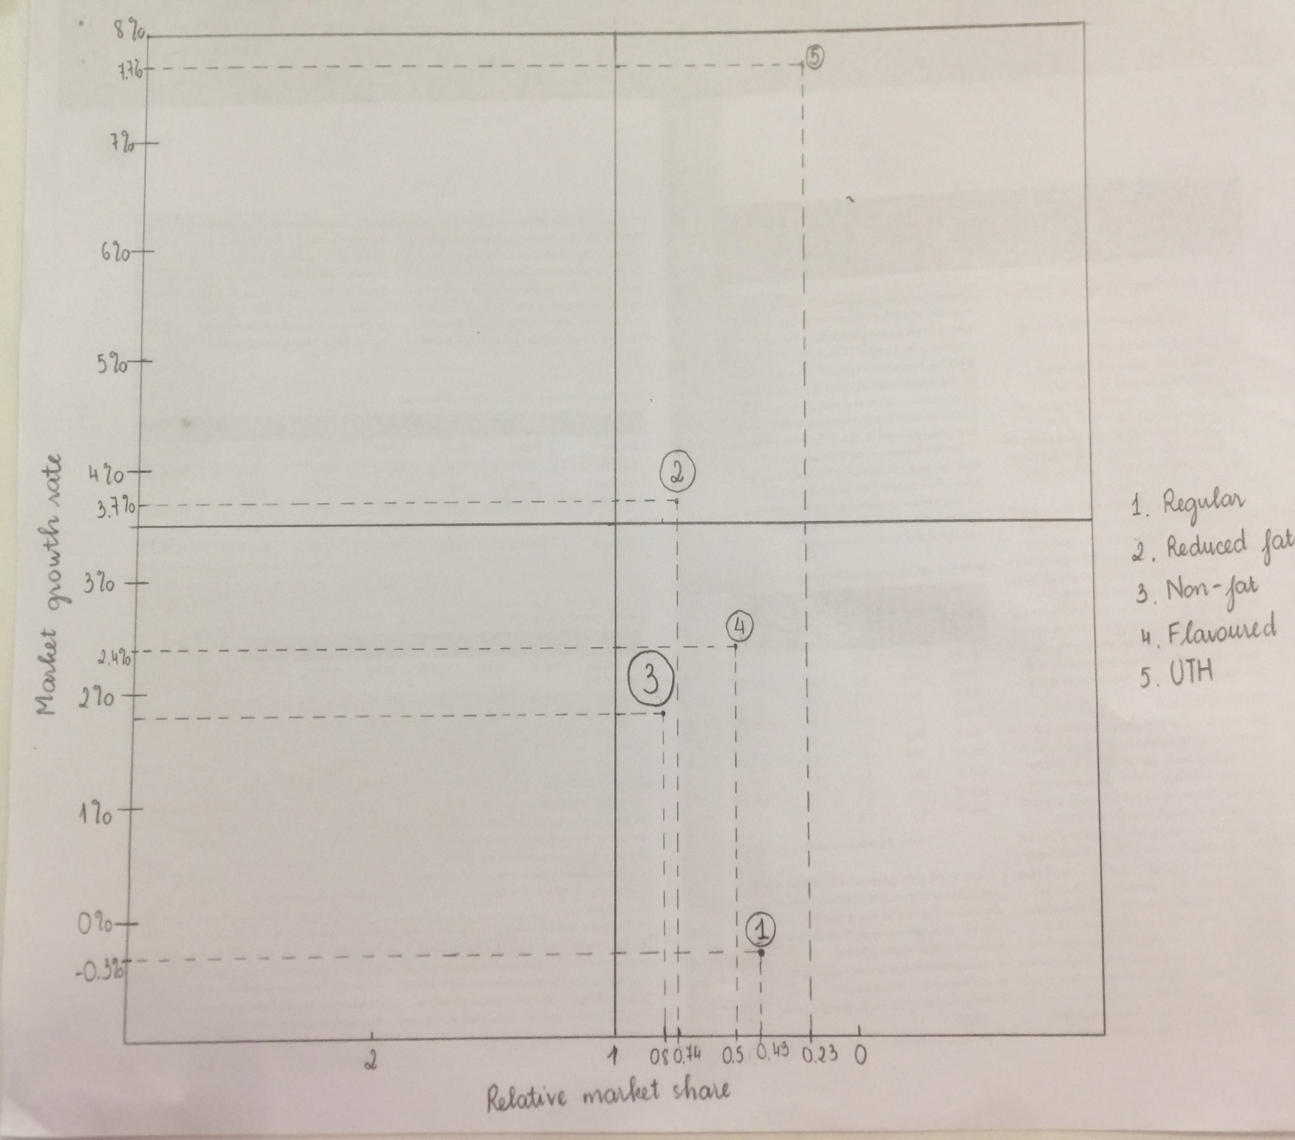

Figure : The Portfolio Matrix for Diary Product DPA

From the Figure 9, it indicates that the Regular, Non-fat and Flavored milk belongs to Dogs and the UTH and Reduced fat belongs to Question marks.

#### Dogs

To be more specific, the Regular milk has the lowest relative market share and the lowest market growth rate, which is about 0.3% and 0.43, respectively. The Non-fat milk has higher relative market share than the Regular milk and higher market growth rate, which is about 3.7% and 0.74, respectively. The Flavored milk has higher relative market share than Regular milk and higher market growth rate, which is about 2.4% and 0.51, respectively.

This proves that in the Australian market, the milk competitors offer the DPA Regular, Non-fat and Flavored milk in the limited markets that are not likely to growth quickly. The large company will sell off the DPA milk to smaller companies and the quantity of DPA items will become the limited products in the market.

Due to the low growth, investment, sales, the DPA items is difficult to achieve the preference and needs from consumer behavior. If the company wants the DPA items to exist in the market, it should be the DPA items adjustment such as adding flavors and conduct more research about the benefit of using Regular, Non-fat and Flavored milk. Moreover, the product belongs to Dogs, it also implies that the DPA Regular, Non-fat and Flavored milk’s product life cycle is in the decline stage.

#### Question marks

The Reduced fat milk has higher relative market share than Regular and Flavored milk but lower than Non-fat milk and higher market growth rate than Regular, Flavored and Non-fat, which is about 3.7% and 0.74, respectively. The UTH ranks first in the Relative market share and Market growth rate, which is about 7.7% and 0.23, respectively.

This represents some possible situation that the UTH or Reduced fat milk could become either a success or a failure depending on the macro and micro environment. The DPA UTH and Reduced fat milk also offer few benefits than DPB, DPC and DPD. The price of DPA items might be too high, which poses a threat in ineffective distribution and promotion. If the DPA UTH and Reduced fat milk want to appear in the long run, the analysis of PESTLE and SWOT will outline the approach for future direction.

In order to increase Relative market share, the investment must strengthen. Otherwise, the items will experience the loss of cash amount in the short run. In the long run, the DPA UTH and Reduced fat milk will become a dog. Moreover, the product belongs to Question marks, it also implies that the DPA UTH and Reduced fat milk’s product life cycle is in the growth stage.

# How do the major supermarket pricing strategies affect the attractiveness of the dairy industry? What steps can dairy producers take to best deal with the market power of the major supermarkets?

##### The major supermarket pricing strategies

There are some major supermarkets in Australia such as ALDI, Foodland, IGA, Coles and Woolworths (Canstar Blue, 2018). The ALDI supermarket ranks first, which is followed by Foodland, IGA, Coles and Woolworths in terms of satisfaction, money value, customer service and accessibility of staff, layout & presentation of store, freshness of fruits, vegetable and meat, variety of products, quality of private label and deals or specials available (Canstar Blue, 2018). Depends on micro-environment, each supermarket will propose own the pricing strategies to attract the dairy producers.

The ALDI supermarket offers the lower prices in real competition against major brands. The Independent Grocers of Australia (IGA) offers slightly higher prices in local brands, specialty products. The Foodland, Coles and Woolworths’ supermarkets offer the relative low prices and high specials deal (Canstar Blue, 2018). Therefore, the framework for setting price of major supermarket is illustrated in Figure 10.

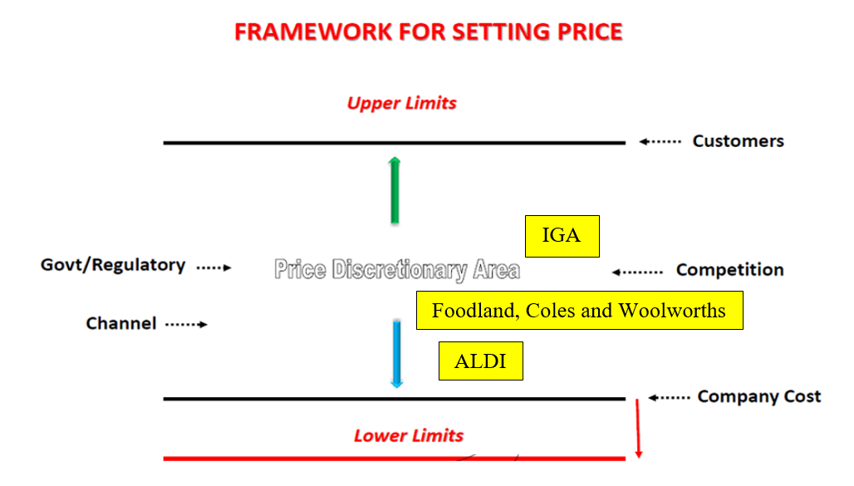

Figure : The Australian Major Supermarkets Setting Price Framework

From the Figure 10, the dairy companies can outline the pricing strategy when choosing the pricing strategies of each supermarket. For the ALDI, Foodland, Coles and Woolworths’ supermarket which targets the price-sensitive customers, the pricing strategy based on customers’ needs regarding value pricing and everyday low pricing (EDLP) should be applied. Therefore, both the supermarkets and dairy companies will reach the large number of target customers and expand the market share. For the IGA, the pricing strategies based on the competitors should be used.

When the major supermarkets compete with the price in the market, some possible measures could be applied

* Still maintain the current price of own supermarkets until the utilization of new pricing strategy.
* Lobbying with government if the price fighting becomes serious.
* Conduct further promotion mix to attract the target market like sampling, coupon.
* Changing the distribution channel which is suitable for the new pricing strategy.
* Create the new creative strategy to advertise the current dairy products.
* Re-arrange the budget of advertising vehicle to promote the product of each major supermarket if possible

##### Steps

Due to fierce competition between major supermarkets, the dairy producers must take some steps to ensure the products distribution in each supermarket

* Outline the positioning of major supermarket
* Catch up with the change of the *Competition and Consumer Act 2010,* the *Trade Practices Act 1974,* the *Copyright Act,* the *Trademarks Act* and the *Fair Trading Acts* in Australia.
* Acknowledge and comprehend the pricing strategy, target customers of each supermarket
* Conduct the research about each supermarket scales, stage of product life cycle
* Consult with each supermarket about price to deliver the appropriate product quantity
* Choose the distribution channels
* Follow the government policies in terms of manufacturing the dairy products, promotion, pricing, distribution

**Reference**

Belch, G.E., Belch, M.A., Kerr, G. & Powel, I. (2014). *Advertising: An Integrated Marketing Communication Perspective (3e)*. North Ryde, Sydney: McGraw Hill

CanstarBlue. (2018). *Supermarkets Satisfaction Ratings*. Retrieved from <https://www.canstarblue.com.au/stores-services/supermarkets/>

EasternEye. (2018). *5 Most Expensive Cheeses in the World*. Retrieved from <https://www.easterneye.biz/5-most-expensive-cheeses-in-the-world/>

Hoskin, D. (2018). *Which Butter Is Better? An Australian List of the Best Butters for Baking*. Retrieved from <http://hoskinshens.blogspot.com/2018/06/which-butter-is-better-australian-list.html>

Jager, C. (2018). *The Nine Best Cheeses in Australia*. Retrieved from <https://www.lifehacker.com.au/2018/02/the-nine-best-cheeses-in-australia/>

Jain, S., Haley, G., Voola, R. & Wickham, M. (2012) *Marketing Planning and Strategy (1e)*. Victoria: Cengage Learning.

Solomon, M., Hughes, A., Chitty, B., Fripp, G., Marshall, G. & Stuart, E. (2014). *Marketing 3: Real People, Real Choices*. Frenchs Forest: Pearson Education Australia.

**Success! Your submission appears on this page. The submission confirmation number is 6dc27921-7c18-443d-934e-4b3316660374. Copy and save this number as proof of your submission.**[**View all of your submission receipts in My Grades.**](https://learn.jcu.edu.au/webapps/bb-mygrades-BB5a1f6a34a2e8d/myGrades?course_id=_92939_1&stream_name=mygrades&is_stream=false)